# METER GROUPING (coloring)

The dataset contains a column named “Group” which is used to identify groups of meters by their color in the generated plots. Ex. simple, compound, and odd meters.

**EXAMPLE 1:**

<https://viva.pressbooks.pub/openmusictheory/chapter/compound-meters-and-time-signatures/>

0 = beat divides in 2 (simple)

1 = beat divides in 3 (compound)

2 = odd # of beats

**EXAMPLE 2:**

<https://intmus.github.io/inttheory18-19/04-intro-rhythm/b2-compoundmeter.html>

Meters that divide the beat into three equal parts are compound meters.

When combined with simple meters, there are six types of standard meter in Western music:

* simple duple (beats group into two, divide into two)
* simple triple (beats group into three, divide into two)
* simple quadruple (beats group into four, divide into two)
* compound duple (beats group into two, divide into three)
* compound triple (beats group into three, divide into three)
* compound quadruple (beats group into four, divide into three)

In a time signature, the top number (and the top number only!) describes the type of meter. Following are the top numbers that always correspond to each type of meter:

* simple duple: 2
* simple triple: 3
* simple quadruple: 4
* compound duple: 6
* compound triple: 9
* compound quadruple: 12

OUTRA FONTE: <https://www.musictheory.net/lessons/15>

# DATASET_1

The dataset of meters was designed so that all meters have the same stratification level in order to preserve time span between pulses. For example: a 4/4 stratified to the 16n will create an array with 16 pulses while a 12/8 stratified to the 16n will have 24 pulses. A ¾ stratified to the 16n will create an array with 12 pulses and a 6/8 stratified to the 16n will have also 12 pulses but on all these arrays the weights given to each pulse will differ according to the kin.weights by Sioros developed after the indispensability algorithm of Clarence Barlow.

# DATASET_2 - TRIMMED / REDUX version

Besides the common simple and compound meters, there are other meters created by grouping different simple or compound meters. For example, a 7/4 can be formed by grouping ¾+4/4 or a 4/4+¾ . For that reason, these types of meters are more ambiguous to analyze because the grouping rely more on phenomenal accents that emerge from the composition phrasings and instrumentation. These are less popular so there’s not so many musical examples available, for that reason we decided to exclude them from the analysis as they become outliers.

Removed meters: 8/4, 11/4, 13/4, 14/4, 15/4, 4/8, 8/8, 11/8, 13/8, 14/8, 15/8

### SHEET: **Meters_16n**

This dataset contains a list of the most common meters used in music, spaning beats groups of 2 up to 12.

Beats groups of 2, 3, and 4 are considered simple, corresponding to a beat's division by two pulses.

Beat groups of 6, 9, and 12 are considered compound, corresponding to a beat division by three pulses.

A few of the common odd meters were added as well, but we suspect that these introduce ambiguity because these odd meters can be created by joining different beat groups. The 7/4 is a typical example, it can be created by joining a 3+4 or a 4+3.

### SHEET: **Cycles_16n**

This dataset contains the same data of the “Meters_16n” dataset but was expanded with constant cycles of time spans. These constant intervals of time are assumed to represent points in the DFT space that act as gravitational centers for those intervals.

This allows to access the distance of our meters dataset to those points.

In theory, the beat/tactus of each meter would align well with the corresponding time span, because the beats are the pulse with more energy(weight) in each pattern.

### SHEET: **Displace_4_4_16n**

This dataset contains the weights (with R=0.3) of a 4/4 meter stratified up to the 16n level, which creates a pattern with 16 pulses. The meter, the stratification level and the weighs are always constant, what changes with each entry in the dataset is the rotation of the initial pattern which goes from no rotation, up until the 16th pulse, rotated gradually pulse by pulse.

### SHEET: **Stratify_4_4**

This dataset contains a 4/4 meter stratified into different metrical levels, to study how this parameters affects the results from the DFT.

In other words, this means that the meter is always the same but by changing the stratification level we can address how the DFT deals with the question about different time spans vs time points.

Changing the metrical level changes the time span between the main beats of a 4/4 meter, in other words, the beats are important time points, that once created in the listener mind tends to stay the same unless conflicted for a long time. The stratification of the metrical levels adds more subsdivions to the meter, hence the distance between beats increases in the DFT input array. For the listener, the time span between beats depends on the BPM, not how many metrical levels present in the rhythmic pattern.

### SHEET: **timeSpan_8n**

This dataset replicates the **Meters_16n** dataset with some changes. This dataset was designed to test the behavior of a **fixed beat length** among meter templates in the DFT space. This is the most important change.

The number of pulses per beat was defined to accommodate simultaneously simple (2, 3, 4) and compound meters (6, 9, 12), which, by computing the ‘*least common multiple*’ (LCM) between 3 and 2, results in 6 pulses per beat. To accommodate higher metrical levels, we doubled that number to 12 pulses per beat.

~~In summary, 12 pulses per beat were assigned to meters with 4n as the beat, and for meters with the 8n as the beat, we assigned 6 pulses per beat. This equates with the perceptual feeling of doubling or twice as fast.~~

~~For meters with the beat at the~~ **~~8n level~~**~~, the beat length was set to~~ **~~6 elements~~**~~, to approximate the perceptual relation of twice as fast.~~ ‼️ Later on, we concluded that this introduces a perceptual tempo change in the DFT space. Because we wish to discard tempo variability we concluded that it is better to use always the same beat length across meters, regardless of the time signature numerator or denominator (2n, 4n, 8n).

Moreover, the coloring code was corrected to assign one color to simple meters (2, 3, 4), another to compound meters (6, 9, 12) and another one to odd meters (5, 7, 10).

The indispensability values array varies in size for each meter and stratification level.

This is an issue for the DFT, and to fix it, we established that all meters should be stratified to the same metrical level and that the number of *pulses per beat* should also be constant. This ensures a more reliable comparison of meters.

First, the indispensability values array is splitted by beats, creating smaller arrays.

For each split array, his values are distributed uniformly in a new *array* with a pre-determined length(12) and pre-filled with zeros. Lastly, all fixed-length arrays are concatenated together to create the complete metrical template.

**beatSync**:

Quantizing the time span of event pulses into fixed beat lengths.

#beats - array_length

#### Fixed Beat Length VS Pulse Fixed Length

# 

# 

# DATASET 3

## Metric Sync

metricSync:

LCM (2 3 4 5 6 7 9 12) = 1260

4n = 1260

8n = 2520

16n = 5040

LCM (8 10 14 12 16 18 20 28 24 36 48) = 5040

# EXPERIENCE 1

The dataset contained multiple meters from *simple*, *compound,* and meters with an odd number of beats, all stratified to **different** metrical levels.

This happened because of the dilemma around the number of pulses, in other words, the timepoints, and the time span. All of these have an impact in the DFT results.

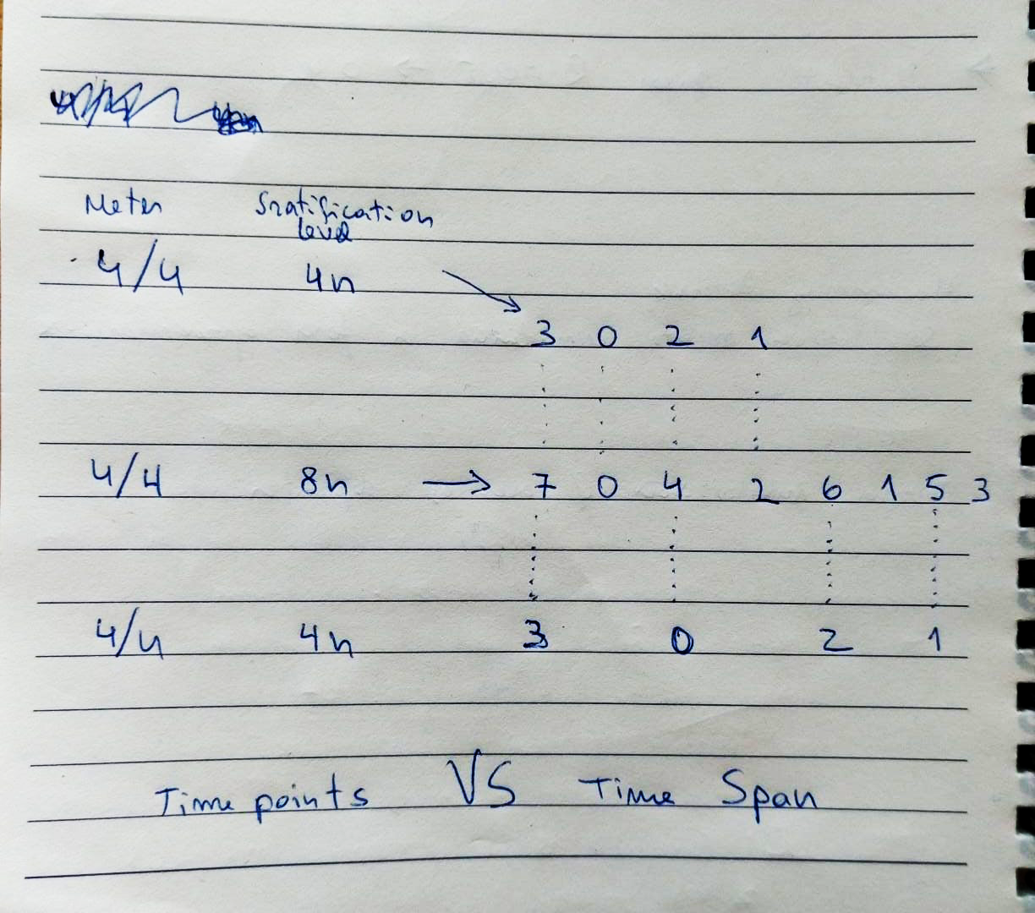

# EXPERIENCE 3 - Weights

This experience uses **weights** values instead of indispensability values (from kin.weights), with **R=0.5** as the default value.

Weights are **repeated** consecutively until the **length** reaches 256 items.

**UMAP** visualization of Amplitudes and DFT complex numbers reveals more meaningful information than MDS and t-SNE, reflected in a higher level of meter clustering than the other visualizations.

# EXPERIENCE 4 - Meters (pulse sync)

This experience is based on EXP_03 using the **weights** instead of indispensability values, but this time with **R=0.3** to reduce energy in the fastest metrical levels (ex. 16n and 8n).

Weights are **repeated** consecutively until the length reaches **512** items.

Each meter was assigned a group label to separate by color simple, compound, and irregular meters.

**UMAP** visualization of Amplitudes and DFT complex numbers reveals more meaningful information than **MDS** and **t-SNE**, reflected in a higher level of meter clustering than the other visualizations.

## EXP_04a

## EXP_04_beatSync

Repeat of experience 4a with the final version of the dataset which includes what we considered (empiracally) the most typical meters used in western music:

Moreover, this dataset was updated to use matplotlib color labels instead of numbering which was always putting yellow:

| **Index** | **Group** | **Meter** | **Strat level** |
| --- | --- | --- | --- |
| 0 | k | 2/2 | 16n |
| 1 | k | 2/4 | 16n |
| 2 | k | 3/4 | 16n |
| 3 | k | 4/4 | 16n |
| 4 | c | 5/4 | 16n |
| 5 | m | 6/4 | 16n |
| 6 | c | 7/4 | 16n |
| 7 | m | 9/4 | 16n |
| 8 | m | 12/4 | 16n |
| 9 | c | 5/8 | 16n |
| 10 | m | 6/8 | 16n |
| 11 | c | 7/8 | 16n |
| 12 | m | 9/8 | 16n |
| 13 | m | 12/8 | 16n |

4/4 aparece sempre proximo dos 12/x em complex e magnitudes.

# EXPERIENCE 5 - Cycles

The sheet “**Cycles_16n**” adds *regular metric intervals* stratified up to **16n** to the original dataset.

**Questions:**

* In dataset “cycles beatSync” only include cycles integer of the predefined beat length (24)?
* In dataset “cycles_a pulseSync” include all cycles up until 16 pulses of time span?

## EXP_05b

This experience repeat the previous one with dataset #2.

# EXPERIENCE 6 - Displacement

This experience accesses the **displacement** of a 4/4 meter stratified up to **16n** based on weights with R=0.3.

The meter is displaced one pulse at a time.

## EXP_06b

This experience repeat the previous one with dataset #2.

**Calculating displacements with a fixed beat length in a 4/4_16n template:**

(pulse spread)

# EXPERIENCE 7 - Stratification

This experiment compares the distances between different stratification levels of a 4/4 meter.

———

Tipo de representacao e vital,

N

Acentos

Exemplos de displacement

2 coisas

Toussaint baseline, experiencia perceptual - focado complexidade e analise perceptual

Rhythm spaces -

Heatmaps, ordenar rows por distancias

# EXPERIENCE 8

Experience 8 tests how the metric templates perform with *fixed beat lengths* among themselves. This dataset comprises a **common stratification** level among templates at the **8n level**.

We used the **weighted** indispensability values with **R=0.3** generated by Sioro’s algorithm, and we **repeated** the templates consecutively until the length reached **512**.

For meters with the beat at the **4n level**, the beat length was set to **12 elements**, which accommodates both *simple* and *compound* meters because it is twice the ‘least common multiple’ (LCM) between 2 and 3.

<https://www.calculatorsoup.com/calculators/math/lcm.php>

For instance, this strategy creates a 4/4 meter with 12*4=48 pulses due to the fixed beat length. The final array varies in size with other time signatures (numerator) but the beat length remains constant.

12 pulses per beat allows for the representation of patterns up to the **16nt** stratification level in a 4/4, to include more metrical levels, one only needs to double the array size.

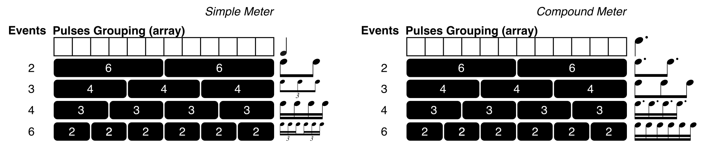

## EXP_08f

This experience changes its dataset so that all meters share effectively the same beat length of **12 pulses**, regardless of beat grouping (numerator). The stratification level remains constant across all meters at the **8n**.

A 2/2, 2/4, or 6/8 all have the same beat length, and all indispensability values (weights) are split by how a musician would feel those meters (the beat or tactus), for instance, a musician feels a 6/8 as a 2/4 with triple subdivision of the beat.

For this reason a 6/4 feels faster than a 6/8, because the 6/4 encompasses one more metrical level than the 6/8 to reach the 8n stratification level.

## DFT Magnitudes

**12/4a** detaches as an outliner.

The indispensability values stratified up to the 8n create an array with 24 elements.

24 / 12 beats = 2 elements distributed per beat

This template ends up with a length of 144 elements. We can confirm the fixed beat length by:

144 / 12 = 12 pulses per beat. So, this template has 12 beats, and each beat comprises 12 pulses.

The indispensabilities are: {23 0 12 4 16 8 20 2 14 6 18 10 22 1 13 5 17 9 21 3 15 7 19 11}

If they are spread across 12 beats, then they will be grouped accordingly:

01: 23 0

02: 12 4

03: 16 8

04: 20 2

05: 14 6

06: 18 10

07: 22 1

08: 13 5

09: 17 9

10: 21 3

11: 15 7

12: 19 11

Two indispensability values per beat because the meter was stratified up to the **8n,** thus comprising the 4n and 8n metrical per beat.

In practice, this is a ***simple*** beat representation, where the beat is subdivided by 2. However, 12/4 is a ***compound*** meter where the beat subdivides first by 3 and subsequent layers by 2. In [music theory](https://www.musictheory.net/lessons/15), all time signatures with numerators 6, 9, or 12 are considered *compound*, and time signatures in *simple* meter have 2, 3, or 4 in the numerator.

Looking closely to the Sioros weights of this template with R=0.3, their energy pulses seems to have low values, considering that this grouping introduces many zeros and thus creates a long array, this might justify partially the big distance from similar meters.

Template **12/4b** presents a different grouping of the indispensability values (pulses). 24 pulses are split into 4 beats:

24 / 4 beats = 6 elements(pulses/values) distributed per beat

1: 23 0 12 4 16 8

2: 20 2 14 6 18 10

3: 22 1 13 5 17 9

4: 21 3 15 7 19 11

The triple division of the beat is quite noticeable in the values with more energy; for instance, the first beat has values 23, 12, and 16, which correspond to the three 8n of the beat. The numbers in between belong to the 16n metrical level.

Compound meters can easily create ambiguities, but this representation is more accurate because in compound meters each beat is represented by a dotted quarter note. This can be confirmed by the indispensability value of the first element of each beat, which is the array's top four greatest values (23, 20, 22, 21).

| 24 2 2 3 2 | 0 4 3 4 3 4 2 4 3 4 3 4 1 4 3 4 3 4 2 4 3 4 3 4 |
| --- | --- |
| :2 | 0 4 3 4 3 4 2 4 3 4 3 4 **/** 1 4 3 4 3 4 2 4 3 4 3 4 |
| :2 | 0 4 3 4 3 4 **//** 2 4 3 4 3 4 **/** 1 4 3 4 3 4 **//** 2 4 3 4 3 4 |
| :3 | 0 4, 3 4, 3 4 **//** 2 4, 3 4, 3 4 **/** 1 4, 3 4, 3 4 **//** 2 4, 3 4, 3 4 |

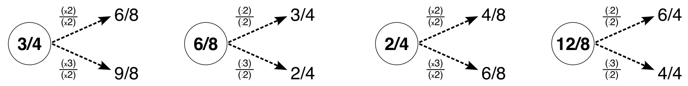

## DFT Complex Numbers

.

### Sorted by 4/4

## Wrapped Phases

.

## Unwrapped Phases

.

# 

## CONCLUSIONS

The fixed beat length is the important constant parameter when comparing rhythmic patterns. Everything else can vary, the number of beats, the number of events.

The fixed beat length increases the DFT analysis accuracy because the rhythmic patterns become BPM invariant. BPM shifts changes the periodicities intervals among events.

I suspect the number of repetitions of each array creates a shift in the unwrapped phases. This was revealed from the second with iteration 432 repetitions.

A fixed beat length reduces the influence of the fastest metrical levels.

Barlow 7/4 = 2+2+3

12/4a nem 12/4b parecem bem representados, precisam de ser verificados.

In hind sigth, real music doesn’t contain at once all the meters found in this dataset.

Como é que se distingue periodocidades entre metricas quando os intervalos alteram-se constantemente com os niveis de estratificação? É que ocorre em harmonia, os intervalos mantem-se constantes porque o pitch space é constante.

# EXP 09

# GB NOTES

## REUNIAO_1

Sonificar os os Weigths 0.3

Fechar as experiencias:

* escrita
* Ponto de partida, problema de ter *varias metricas* ao barulho;
  + Vamos estudar varios tipos de representação;
    - Metodologia: templates metricos, calculo das distancias, binarias vs ternarias
  + Weights: zero padding VS **repeticao** (problema de ter N constante); not a problem in harmony
  + Fixed pulse duration VS **fixed beat length**
* Arvore do tipo de inputs: parametros da definição de entrada
  + Ritmo simples vs loop
* Ver tese da jenn (implicacoes para analise de varios parametros de entrada)
* Explicar os outliers;

Expectativa DFT: Um poli-ritmio irá localizar-se num ponto intermédio.

Cap: input representations

Cap:

Ver: Rhythmic Patterns () implementado no dominio do audio, lida com ratios de osciladores

<http://ifs.tuwien.ac.at/mir/audiofeatureextraction.html>

X…x…x…x…..

## REUNIAO_2 - 2024_12_05

Assuntos:

* Rui Penha ? carta interna Coelho
* Perspectiva de entrega / alternativa António Coelho / Preparações (cartas, título, feup, fct?)
  + Entrega
  + Definir o juri
  + Concelho cientificio
  + Serviços academico
* Capitulo 4.2
* Titulo? Requerimento (2 semanas antes, carta orientadores e A.Coelho)
* BeatSync: Acho que não é necessário repetir o template adlib, basta duplicar uma para captar o ciclo do compasso

## REUNIAO_3 - 2024_12_12

* Rui Penha respondeu ontem
* Critério de escolha das figuras? influencia na narrativa:
  + Complex VS Magnitudes
  + Phase VS Unwrapped phase
  + Unsorted VS Sorted
* Rever estrutura das Experiencias

## REUNIÃO 4 - ?

Papelada para submissão e extensão do prazo com o A.Coelho

1. Apanhado das experiências feitas desde o inicio.
2. Quais as experiências a reportar?

Olhar para a tese de cima abaixo para gerir o tempo necessário.

Qual o grande objectivo destas experiências? Dar enfase no doc a esses objetivos? (sec. intro e métodos)

## REUNIAO 2025-03-05

## REUNIAO 2025-04-14

Envio do PDF: troca CD dia 22. Fernanda serviços académicos

Chap 3

Contéudos

Introdução caso cenário ?

Discussão?

# Kendall’s Tau 23pax

The mean of 'Q02' (experience) is: 4.83

The standard deviation of 'Q02' is: 1.47

The mean of 'Q04' (age) is: 3.04

The standard deviation of 'Q04' is: 0.77

Mean exp ≈ 17.98 years

Std dev exp ≈ 8.37 years

Mean age ≈ 35.43 years

Std dev age ≈ 7.67 years

- - - b_histo - - -

Total participants: 23

High agreement (τ ≥ 0.7) : 10 (43.48%)

Medium agreement (0.5–0.7): 6 (26.09%)

Low agreement (τ < 0.5) : 7 (30.43%)

Mean (τ) : 0.62

Std (τ) : 0.22

- - - p_histo - - -

Total participants: 23

High agreement (τ ≥ 0.7) : 1 (4.35%)

Medium agreement (0.5–0.7): 6 (26.09%)

Low agreement (τ < 0.5) : 16 (69.57%)

Mean (τ) : 0.33

Std (τ) : 0.27

- - - m_histo - - -

Total participants: 23

High agreement (τ ≥ 0.7) : 8 (34.78%)

Medium agreement (0.5–0.7): 7 (30.43%)

Low agreement (τ < 0.5) : 8 (34.78%)

Mean (τ) : 0.53

Std (τ) : 0.31

- - - Combined Summary - - -

dataset total high medium low mean std

0 b_histo 23 10 6 7 0.624224 0.218100

1 p_histo 23 1 6 16 0.326087 0.268773

2 m_histo 23 8 7 8 0.534161 0.313741

- - - Aggregated Statistics Across All Datasets - - - (NAO FAZ SENTIDO-ERA DO BARLOW)

Average total participants: 23.00

Average high agreement percentage: 27.54%

Average medium agreement percentage: 27.54%

Average low agreement percentage: 44.93%

Overall mean of τ: 0.49

Overall standard deviation of τ: 0.27

## NORMALITY DISTRIBUTION TEST (for p_, b_, m_ methods)

Total number of users: 23

Method B: W = 0.907, p = 0.035

Method P: W = 0.954, p = 0.362

Method M: W = 0.849, p = 0.003

Differences B–P: W = 0.945, p = 0.225

\begin{comment}

W is the Shapiro–Wilk statistic (close to 1 if normal).

p is the p‑value; if p < 0.05 you reject normality at the 5% level.

Method B: W = 0.907, p = 0.035

Method P: W = 0.954, p = 0.362

Method M: W = 0.849, p = 0.003

\end{comment}

## STATISTICAL SIGNICANCE

Friedman non-parametric test

Friedman χ² = 12.667, p = 0.002

→ Significant differences exist across the three methods

B vs P: W = 21.5, raw p = 0.002, p₍adj₎ = 0.005 → ✓

B vs M: W = 64.0, raw p = 0.125, p₍adj₎ = 0.376 → n.s.

P vs M: W = 64.0, raw p = 0.042, p₍adj₎ = 0.127 → n.s.

**Write me a report of a Friedman test which reported the following results:**

A Friedman test was conducted to evaluate differences in Kendall’s Tau coefficients among the three methodologies (B, P, and M). The test revealed significant differences across methodologies, χ²(2) = 12.67, p = 0.002. Pairwise post-hoc Wilcoxon signed-rank tests with Bonferroni correction showed that Method B significantly differed from Method P (W = 21.5, adjusted p = 0.005). However, no statistically significant differences were found between Method B and Method M (W = 64.0, adjusted p = 0.376) or between Method P and Method M (W = 64.0, adjusted p = 0.127).

Can you help me with the interpretation of this statistical significance test?

# BARLOW Ranking - Kendal Tau

- - - b_histo - - -

Total participants: 23

High agreement (τ ≥ 0.7) : 7 (30.43%)

Medium agreement (0.5–0.7): 11 (47.83%)

Low agreement (τ < 0.5) : 5 (21.74%)

- - - p_histo - - -

Total participants: 23

High agreement (τ ≥ 0.7) : 2 (8.70%)

Medium agreement (0.5–0.7): 7 (30.43%)

Low agreement (τ < 0.5) : 14 (60.87%)

- - - m_histo - - -

Total participants: 23

High agreement (τ ≥ 0.7) : 9 (39.13%)

Medium agreement (0.5–0.7): 7 (30.43%)

Low agreement (τ < 0.5) : 7 (30.43%)

## NORMALITY DISTRIBUTION TEST (Barlow)

Method B: W = 0.911, p = 0.044

Method P: W = 0.961, p = 0.488

Method M: W = 0.843, p = 0.002

Differences B–P: W = 0.979, p = 0.888

## STATISTICAL SIGNIFICANCE (Barlow)

Friedman χ² = 8.066, p = 0.018

→ Significant differences exist across the three methods

# if p < 0.05, do pairwise Wilcoxon signed‑rank tests with Bonferroni

B vs P: W = 47.0, raw p = 0.004, p₍adj₎ = 0.013 → ✓

B vs M: W = 87.5, raw p = 0.204, p₍adj₎ = 0.613 → n.s.

P vs M: W = 77.0, raw p = 0.064, p₍adj₎ = 0.191 → n.s.

## COMBINED STATS

- - - b_histo - - -

Total participants: 23

High agreement (τ ≥ 0.7) : 7 (30.43%)

Medium agreement (0.5–0.7): 11 (47.83%)

Low agreement (τ < 0.5) : 5 (21.74%)

- - - p_histo - - -

Total participants: 23

High agreement (τ ≥ 0.7) : 2 (8.70%)

Medium agreement (0.5–0.7): 7 (30.43%)

Low agreement (τ < 0.5) : 14 (60.87%)

- - - m_histo - - -

Total participants: 23

High agreement (τ ≥ 0.7) : 9 (39.13%)

Medium agreement (0.5–0.7): 7 (30.43%)

Low agreement (τ < 0.5) : 7 (30.43%)

- - - Combined Summary - - -

dataset total high medium low mean std

0 b_histo 23 7 11 5 0.615559 0.204389

1 p_histo 23 2 7 14 0.379050 0.283166

2 m_histo 23 9 7 7 0.528543 0.332435

- - - Aggregated Statistics Across All Datasets - - -

Average total participants: 23.00

Average high agreement percentage: 26.09%

Average medium agreement percentage: 36.23%

Average low agreement percentage: 37.68%

Overall mean of τ: 0.51

Overall standard deviation of τ: 0.27

# CATEGORICAL 23pax

#### Kendall Tau-b (adequate method)

- - - b_histo - - -

Total participants: 23

High agreement (τ ≥ 0.7) : 6 (26.09%)

Medium agreement (0.5–0.7): 11 (47.83%)

Low agreement (τ < 0.5) : 6 (26.09%)

Mean (τ) : 0.62

Std (τ) : 0.23

- - - p_histo - - -

Total participants: 23

High agreement (τ ≥ 0.7) : 1 (4.35%)

Medium agreement (0.5–0.7): 7 (30.43%)

Low agreement (τ < 0.5) : 15 (65.22%)

Mean (τ) : 0.39

Std (τ) : 0.24

- - - m_histo - - -

Total participants: 23

High agreement (τ ≥ 0.7) : 7 (30.43%)

Medium agreement (0.5–0.7): 8 (34.78%)

Low agreement (τ < 0.5) : 8 (34.78%)

Mean (τ) : 0.53

Std (τ) : 0.34

#### Method C

- - - b_histo - - -

Total participants: 23

High agreement (τ ≥ 0.7) : 12 (52.17%)

Medium agreement (0.5–0.7): 9 (39.13%)

Low agreement (τ < 0.5) : 2 (8.70%)

Mean (τ) : 0.67

Std (τ) : 0.24

| **23pax categorical [1,2,3,4]** | **23pax direct [1,2,3,4,5,6,7,8]** |
| --- | --- |
| - - - b_histo - - -  Total participants: 23  High agreement (τ ≥ 0.7) : 6 (26.09%)  Medium agreement (0.5–0.7): 11 (47.83%)  Low agreement (τ < 0.5) : 6 (26.09%)  Mean (τ): 0.62  Std (τ) : 0.23  - - - p_histo - - -  Total participants: 23  High agreement (τ ≥ 0.7) : 1 (4.35%)  Medium agreement (0.5–0.7): 7 (30.43%)  Low agreement (τ < 0.5) : 15 (65.22%)  Mean (τ) : 0.39  Std (τ) : 0.24  - - - m_histo - - -  Total participants: 23  High agreement (τ ≥ 0.7) : 7 (30.43%)  Medium agreement (0.5–0.7): 8 (34.78%)  Low agreement (τ < 0.5) : 8 (34.78%)  Mean (τ) : 0.53  Std (τ) : 0.34 | - - - b_histo - - -  Total participants: 23  High agreement (τ ≥ 0.7) : 10 (43.48%)  Medium agreement (0.5–0.7): 6 (26.09%)  Low agreement (τ < 0.5) : 7 (30.43%)  Mean (τ) : 0.62  Std (τ) : 0.22  - - - p_histo - - -  Total participants: 23  High agreement (τ ≥ 0.7) : 1 (4.35%)  Medium agreement (0.5–0.7): 6 (26.09%)  Low agreement (τ < 0.5) : 16 (69.57%)  Mean (τ) : 0.33  Std (τ) : 0.27  - - - m_histo - - -  Total participants: 23  High agreement (τ ≥ 0.7) : 8 (34.78%)  Medium agreement (0.5–0.7): 7 (30.43%)  Low agreement (τ < 0.5) : 8 (34.78%)  Mean (τ) : 0.53  Std (τ) : 0.31 |